

Author: W. Conor McFerren Date: 2019/06/14

## RK4th Integrator

### Summer 2019

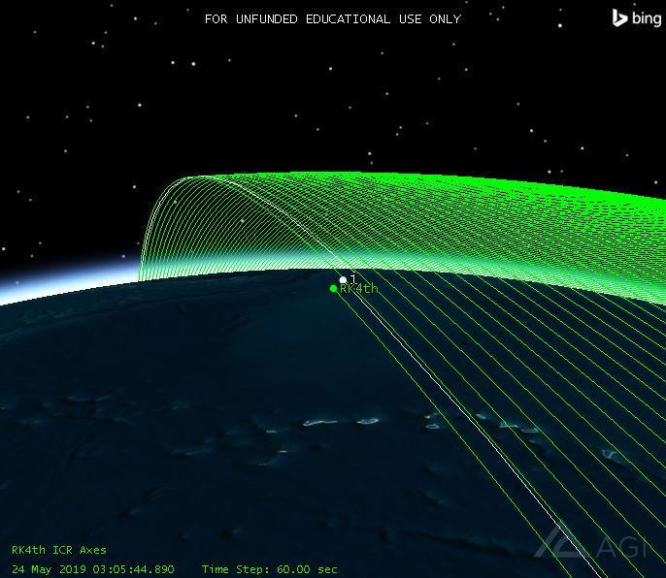

# Revision Table

|  |  |  |
| --- | --- | --- |
| **Changes** | **Authors** | **Version** |
| [2019/06/14] Created | W. Conor McFerren | 0.0.0 |
|  |  |  |
|  |  |  |
|  |  |  |
|  |  |  |
|  |  |  |
|  |  |  |

# Introduction

The purpose of this test is to demonstrate the error involved by using the RK4th integrator. The integrator is a part of the STK propagator that iteratively estimates the position of the satellite. The RK4th integrator is merely one of many integrators used in STK. For this test, we had to “create” our own propagator, meaning we combined gravity models and the integrator to form a fully functioning propagator. Thus, for this test, we chose the JGM3 gravity model.

# Procedure

In order to test the propagator, we pulled past TLE files for the CubeSat 43466 from May 24, 2019 to June 1, 2019. This resulted in 17 TLE files containing data for the satellite. Using these 17 TLE files, 17 satellites were constructed in an STK scenario representing “position checkpoints” for our propagated satellite.

With the checkpoints established, we placed an Astrogator satellite into the scenario at the first checkpoint and set its propagator to the RK4th propagator we made. Using the TLE data for the first checkpoint, we attempted to reflect the initial state of the first checkpoint with our RK4th satellite.

This RK4th satellite was propagated in the scenario and ephemeris data was gathered at each checkpoint, along with ephemeris data for the checkpoint satellites, or the actual satellite. These two sets of ephemeris data gathered are what were processed for the error computation.

# Initial Concerns

When the scenario was first started, there is an obvious concern: The TLE checkpoint satellite (or actual satellite) and the RK4th satellite are in different positions. The RK4th satellite’s initial state was made using data directly from the TLE, but for a non-apparent reason, the two satellites are not in the same initial position.

# Results

For the results, the error percentage in position at each checkpoint was calculated in Cartesian space and a Spherical Polar Coordinate space. Along with this, the distance in orbit between the two satellites and the Great-Circle distance between the points on the Earth directly below the satellites was calculated.

**Cartesian**

|  |  |  |  |  |
| --- | --- | --- | --- | --- |
| **Time (days)** | **X Error (%)** | **Y Error (%)** | **Z Error (%)** | **Distance (m)** |
| 0.0 | 0.02322612241 | 8.21539623997 | 210739.804234 | 37043.7218466 |
| 0.12768259272 | 2.01809795602 | 1.44154837611 | 4929825.98485 | 155090.458252 |
| 0.957612315193 | 2.21086481845 | 97.6856913796 | 37129957.578 | 1043882.98564 |
| 1.21297287056 | 324.046305488 | 2.51351633065 | 35816136.6368 | 1344212.1024 |
| 1.72369090281 | 224.473930326 | 2.83948862952 | 22907184.7626 | 1978442.5968 |
| 1.97904817155 | 2.87159857068 | 152.814183668 | 274291265.699 | 2312798.48701 |
| 2.1705656019 | 106.218178191 | 12.1783554126 | 870391379.151 | 2571126.84913 |
| 2.74511502357 | 102.5642433 | 2.40019385769 | 98306023.2013 | 3380881.20746 |
| 2.93663035892 | 15.5305545991 | 1476.41724669 | 196630680.002 | 3662548.59564 |
| 3.95803430583 | 20.3287058485 | 229.445486306 | 140204132.483 | 5246439.36556 |
| 4.14954473404 | 332.937901173 | 39.9759841741 | 376572456.069 | 5556276.7001 |
| 4.91557821771 | 48.2254891226 | 1036.76451953 | 84892136.9033 | 6820285.62261 |
| 5.10708450247 | 129.50393708 | 72.9505209636 | 611284879.14 | 7141292.86094 |
| 5.93693399336 | 61.4107045712 | 278.869836063 | 2497894951.24 | 8530138.00331 |
| 6.12843496539 | 1139.25341378 | 89.2038664102 | 95435238.5814 | 8847491.51338 |
| 7.02209440991 | 30.9613274188 | 160.243169229 | 68598153.1392 | 10276223.3607 |
| 7.08592633111 | 159.847594487 | 131.741632771 | 118799436.579 | 10373903.2153 |

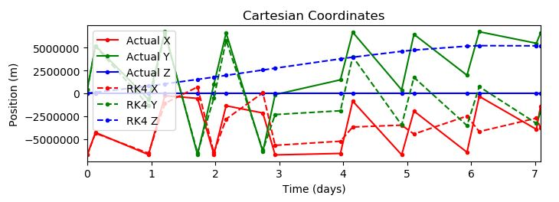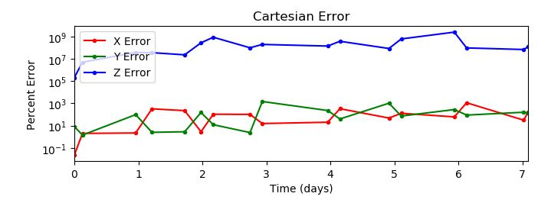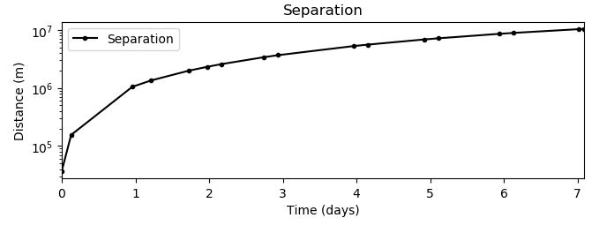

**Spherical Polar**

|  |  |  |  |  |
| --- | --- | --- | --- | --- |
| **Time (days)** | **ρ Error (%)** | **θ Error (%)** | **φ Error (%)** | **Great-Circle Distance (m)** |
| 0.0 | 0.011007393849 | 8.21573051147 | 199.943709749 | 37043.7740284 |
| 0.12768259272 | 0.016297067151 | 1.92640754672 | 0.985222876332 | 155094.28789 |
| 0.957612315193 | 0.035011898877 | 100.147967904 | 192.428869857 | 1045054.22039 |
| 1.21297287056 | 0.045806135703 | 8.33175782227 | 9.78713792828 | 1346717.98637 |
| 1.72369090281 | 0.059396436561 | 198.446695123 | 14.4611294146 | 1986479.67394 |
| 1.97904817155 | 0.065404042612 | 154.639436691 | 183.083320746 | 2325690.05126 |
| 2.1705656019 | 0.075044503188 | 18.1421426545 | 18.8075341492 | 2588902.44397 |
| 2.74511502357 | 0.091084594996 | 225.410610066 | 175.301028736 | 3421863.41806 |
| 2.93663035892 | 0.096696768950 | 1672.00570498 | 173.269304645 | 3714955.48678 |
| 3.95803430583 | 0.134198822446 | 258.38762523 | 162.160817571 | 5407281.20746 |
| 4.14954473404 | 0.145405294551 | 42.6850626047 | 39.9168162543 | 5749392.26423 |
| 4.91557821771 | 0.171687088822 | 1524.42664093 | 47.8138541846 | 7196882.59767 |
| 5.10708450247 | 0.18308828962 | 70.7997558327 | 150.39702154 | 7580633.06102 |
| 5.93693399336 | 0.210937369345 | 422.071978606 | 144.379306812 | 9345859.45439 |
| 6.12843496539 | 0.220818139744 | 88.7018851553 | 143.561959273 | 9779808.83218 |
| 7.02209440991 | 0.249379879693 | 193.046786959 | 56.1666159209 | 8060776.05449 |
| 7.08592633111 | 0.253127705341 | 137.489666086 | 55.8603037776 | 7894076.40829 |

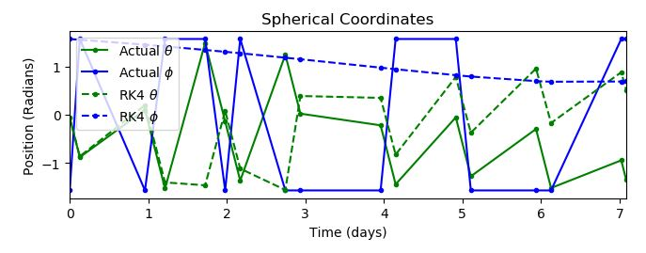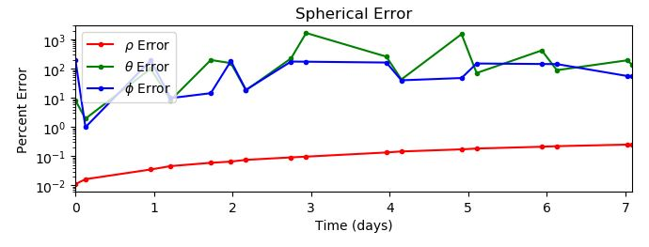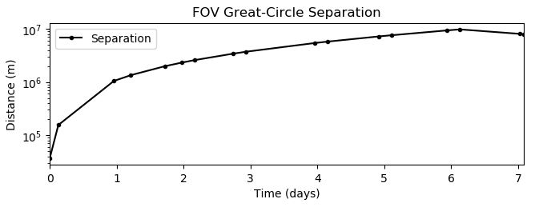

# Conclusion

As can be seen from the data and graphs above, the RK4 integrator is an ineffective and inaccurate way to estimate the orbit of the satellite. Due to the fact that it even starts at a different position from the TLE satellite leads to minimal time where the fields of view will actually line up for imaging.